
Examples of ULD’s (approximate sizes, not definitive as are for example purposes only)

Container Specifications - Air containers (English)
AMA Container
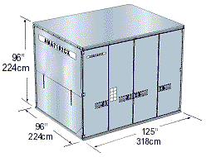 | ATA code  M1  Weight Limitation Inc. ULD Tare Weight  6,804kg  Tare Weight  360kg  Internal Volume  621 cu. ft. 17.58 cbm  Loadable Aircraft Type  747F

AMF Container
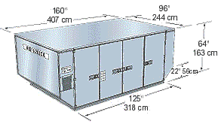 | ATA code  n/a  Weight Limitation Inc. ULD Tare Weight  5,035kg  Tare Weight  360kg  Internal Volume  516 cu. ft. 14.6 cbm  Loadable Aircraft Type  747, 747F, 777, Airbus

AMU Container
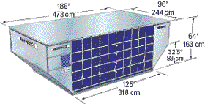 | ATA code  LD39  Weight Limitation Inc. ULD Tare Weight  5,035kg  Tare Weight  290kg  Internal Volume  557 cu. ft. 17.77 cbm  Loadable Aircraft Type  747, 747F

ALF Container
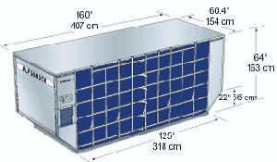 | ATA code  LD6  Weight Limitation Inc. ULD Tare Weight  3,175kg  Tare Weight  155kg  Internal Volume  310 cu. ft. 8.78 cbm  Loadable Aircraft Type  747, 747F, 777, Airbus

AAU Container
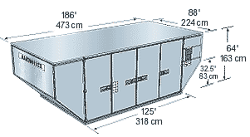 | ATA code  LD29  Weight Limitation Inc. ULD Tare Weight  4,626kg  Tare Weight  355kg  Internal Volume  505 cu. ft. 14.3 cbm  Loadable Aircraft Type  747, 747F

AAP Container
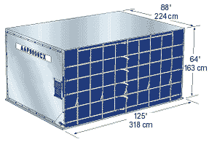 | ATA code  LD9  Weight Limitation Inc. ULD Tare Weight  4,626kg  Tare Weight  222kg  Internal Volume  370 cu. ft. 10.51 cbm  Loadable Aircraft Type  747, 747F, 777, Airbus

AKE Container
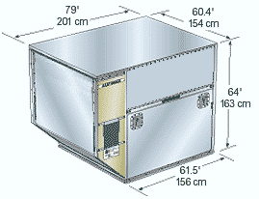 | ATA code  LD3  Weight Limitation Inc. ULD Tare Weight  1,588kg  Tare Weight  100kg  Internal Volume  152 cu. ft. 4.3 cbm  Loadable Aircraft Type  747, 747F, 777, Airbus

AVJ Container
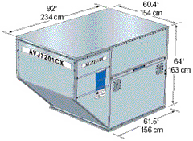 | ATA code  LD1  Weight Limitation Inc. ULD Tare Weight  1,588kg  Tare Weight  100kg  Internal Volume  162 cu. ft. 4.80 cbm  Loadable Aircraft Type  747m, 747F

AAP2 Container
ATA code
LD9
Weight Limitation Inc. ULD Tare Weight
4,626kg
Tare Weight
222kg
Internal Volume
371 cu. ft. 10.51 cbm
Loadable Aircraft Type
747, 747F, 777, Airbus

RAP Container
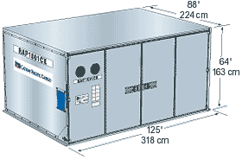 | ATA code  LD9  Weight Limitation Inc. ULD Tare Weight  4,626kg  Tare Weight  330kg  Internal Volume  352 cu. ft. 9.2 cbm  Loadable Aircraft Type  747, 747F, 777, Airbus

RKN Container
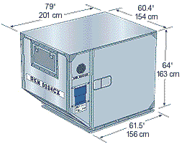 | ATA code  LD3  Weight Limitation Inc. ULD Tare Weight  1,588kg  Tare Weight  190kg  Internal Volume  125 cu. ft. 3.55 cbm  Loadable Aircraft Type  747, 747F, 777, Airbus

Aircraft Pallet Specifications
P7E, PGA Pallet
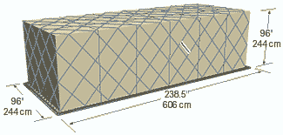 | Size  Base: 96" x 238.5" Height: 96" (Q6 Contour),  118" (Q7 Contour)  Weight Limitation Inc. ULD Tare Weight  11,340 kg  Tare Weight  480 kg  Loadable Aircraft Type  747F

PMC, PQP, P6P Pallet
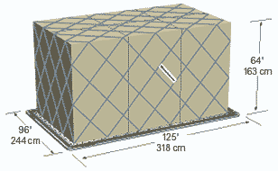 | Size  Base: 96" x 125" Height: 64" (Passenger flight),  96" (Q6 Contour) , 118" (Q7 Contour)  Weight Limitation Inc. ULD Tare Weight  11,340 kg  Tare Weight  480 kg  Loadable Aircraft TYpe  747F

PEB Pallet
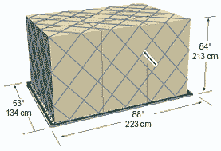 | Size  Base: 53" x 88" Height: 84"  Weight Limitation Inc. ULD Tare Weight  1,800 kg (B-HIH - 1,300 kg)  Tare Weight  55 kg  Loadable Aircraft Type  747F

P1P, PAG Pallet
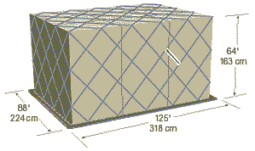 | Size  Base: 88" x 125" Height: 64" (Passenger flight),  96" (Q6 Contour) , 118" (Q7 Contour)  Weight Limitation Inc. ULD Tare Weight  4,626 kg (LD), 6,033 kg  Tare Weight  105 kg  Loadable Aircraft Type  747, 747F, 777, Airbus

VZA, VRA
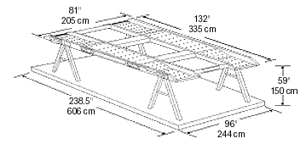 | Size  Fitted on PGA 20ft. Pallet  Weight Limitation Inc. ULD Tare Weight  2,500 kg (Upper Car) 9,300 kg (Max Gross Weight of Pallet)  Tare Weight  319 kg (2 trestles: 139 kg Platform: 180 kg)  Loadable Aircraft Type  747F Upper Deck  Max Width for Lower Car  81" / 205 cm  Max Center Height for Lower Car  59" / 150 cm  Max Wheel Base  123" / 312 cm

